**Experiment No 10**

**Shashwat Tripathi  
D15A 64  
Batch C**

**AIM:** To perform Port, Service monitoring, Windows/Linux server monitoring using Nagios.

**Output-**

**Step 1:** To Confirm that Nagios is running on the server side, run this sudo systemctl status nagios on the “NAGIOS HOST”.

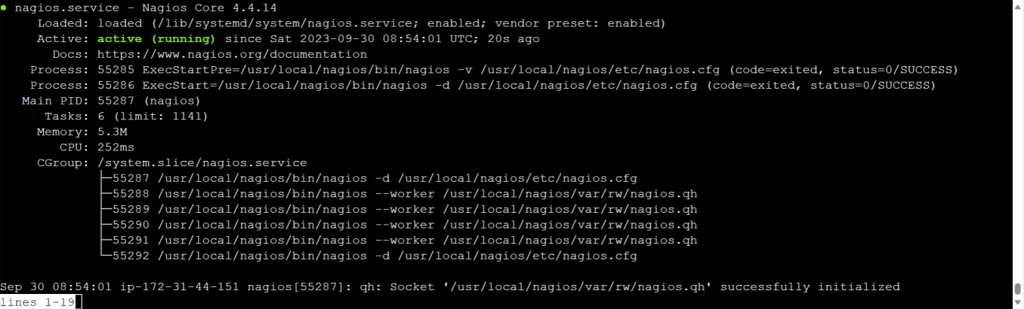

**Step 2:** To monitor a Linux machine, create an Ubuntu 20.04 server EC2 Instance in AWS.

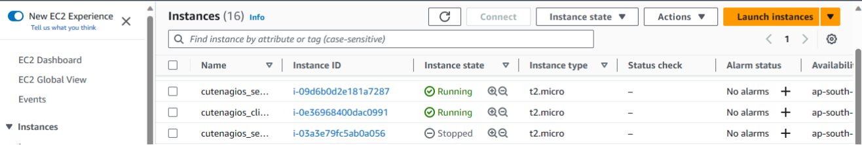

**Step 3:** On client side Step-03 Make a package index update and install gcc, nagios-nrpe-server and the plugins.

sudo apt update -y

sudo apt install gcc -y

sudo apt install -y nagios-nrpe-server nagios-plugins

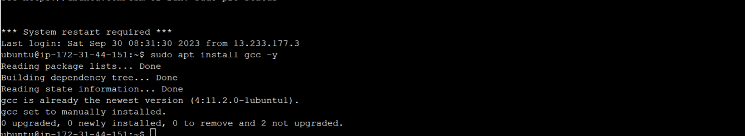

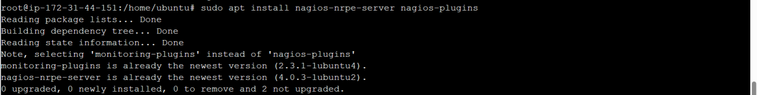

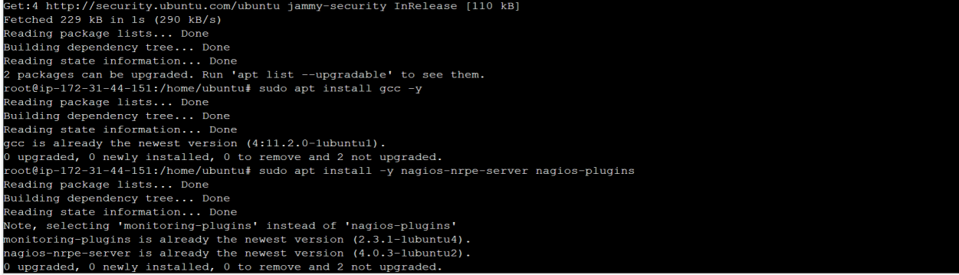

**Step 4:** Open nrpe.cfg file to make changes.

sudo nano /etc/nagios/nrpe.cfg

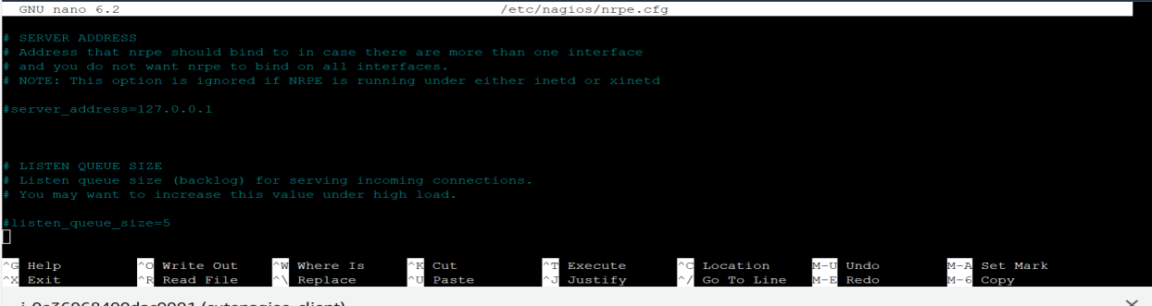

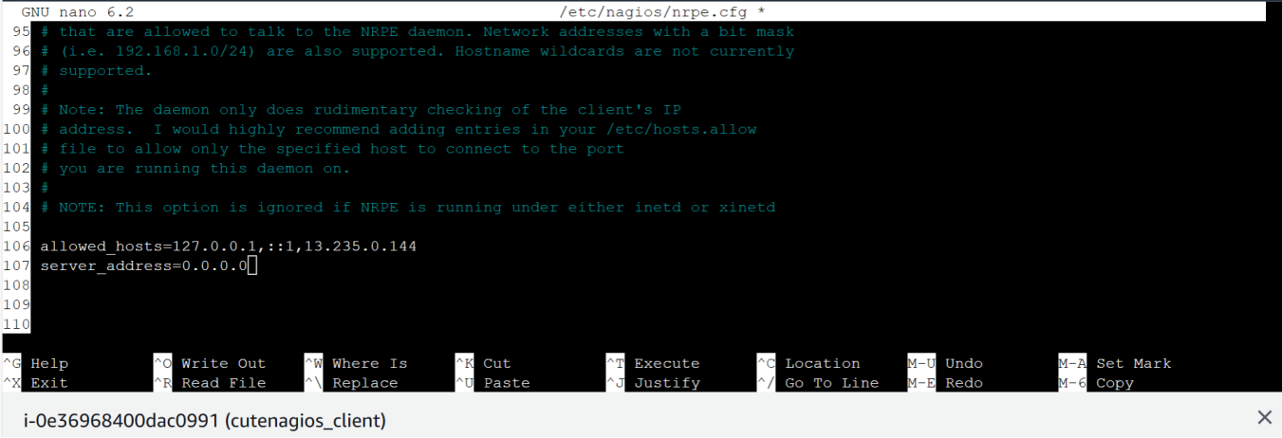

**Step 5:** Restart the NRPE server

sudo systemctl restart nagios-nrpe-server

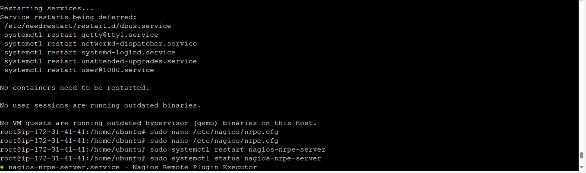

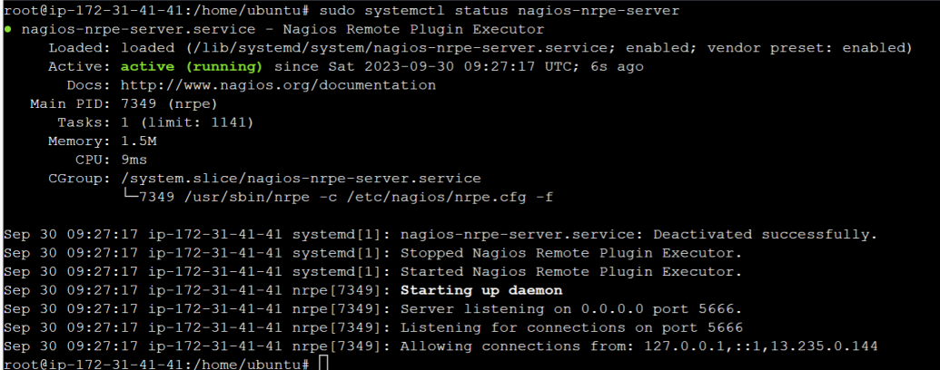

**Step 6:** On the server run this command

ps -ef | grep nagios

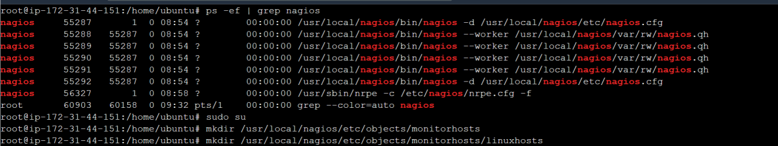

**Step 7:** Become a root user and create 2 folders 1.sudo su 2.mkdir /usr/local/nagios/etc/objects/monitorhosts 3.mkdir /usr/local/nagios/etc/objects/monitorhosts/linuxhosts Copy the sample localhost.cfg file to linuxhost folder 4.cp /usr/local/nagios/etc/objects/localhost.cfg /usr/local/nagios/etc/objects/monitorhosts/linuxhosts/linuxserver.cfg

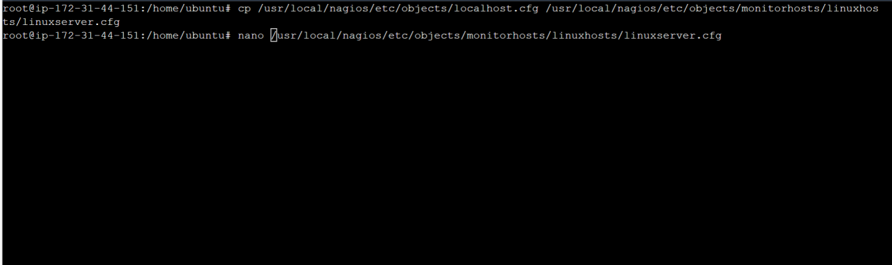

**Step 8:** Open linuxserver.cfg using nano and make the following changes

nano /usr/local/nagios/etc/objects/monitorhosts/linuxhosts/linuxserver.cfg Change the hostname to linux server (EVERYWHERE ON THE FILE) Change address to the public IP address of your LINUX CLIENT.

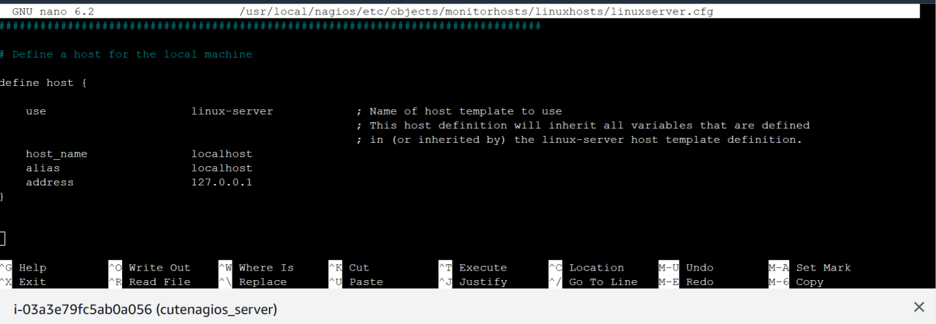

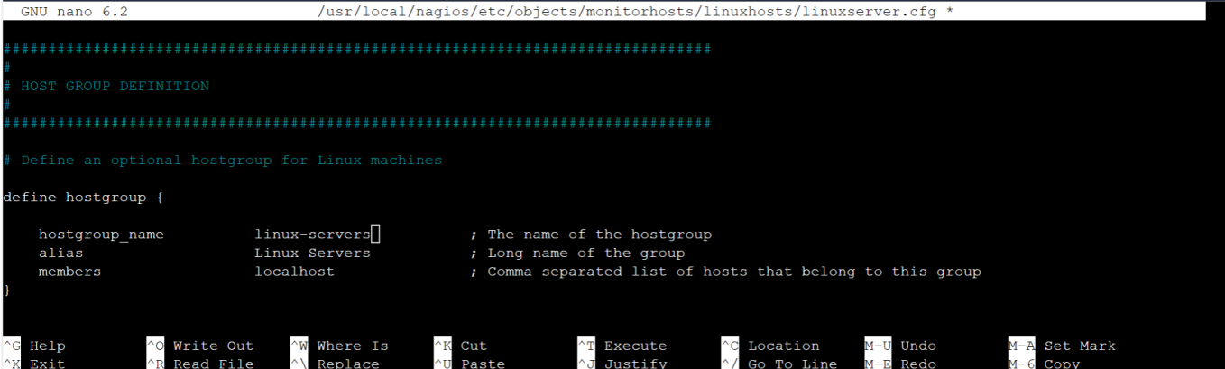

Change hostgroup_name under hostgroup to linux-servers1

**Step 9:** Open the Nagios Config file and add the following line nano /usr/local/nagios/etc/nagios.cfg Add this line cfg_dir=/usr/local/nagios/etc/objects/monitorhosts/

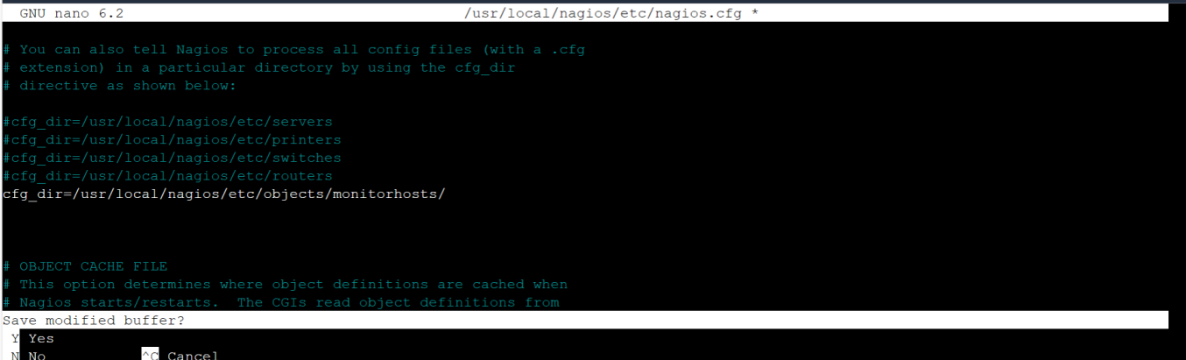

**Step 10:** Verify the configuration files.

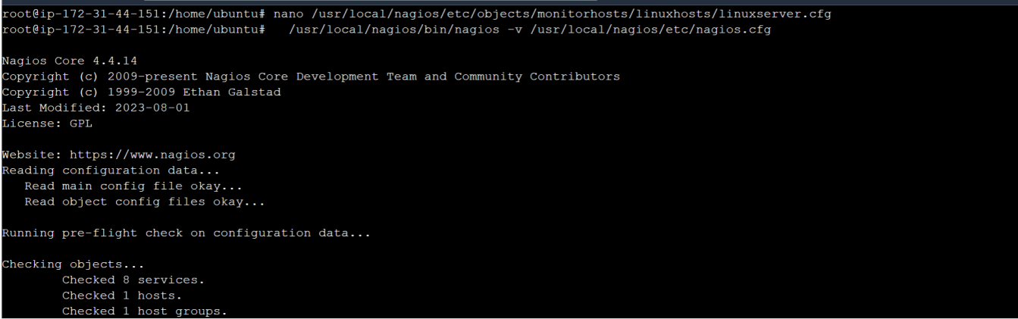

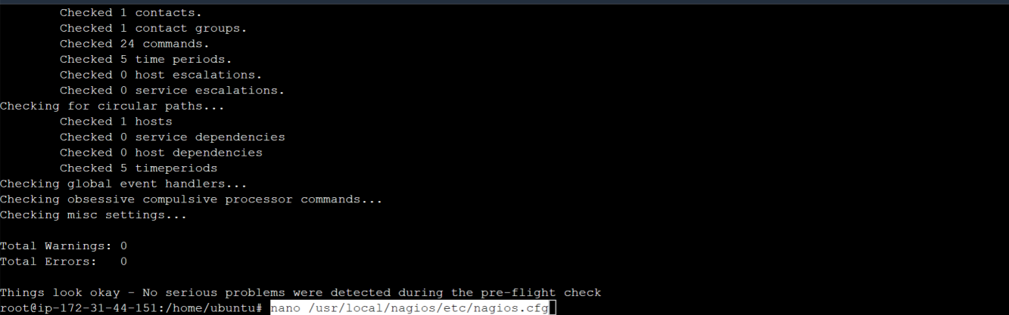

**Step 11:** Restart the nagios service service nagios restart

Sudo systemctl status nagios

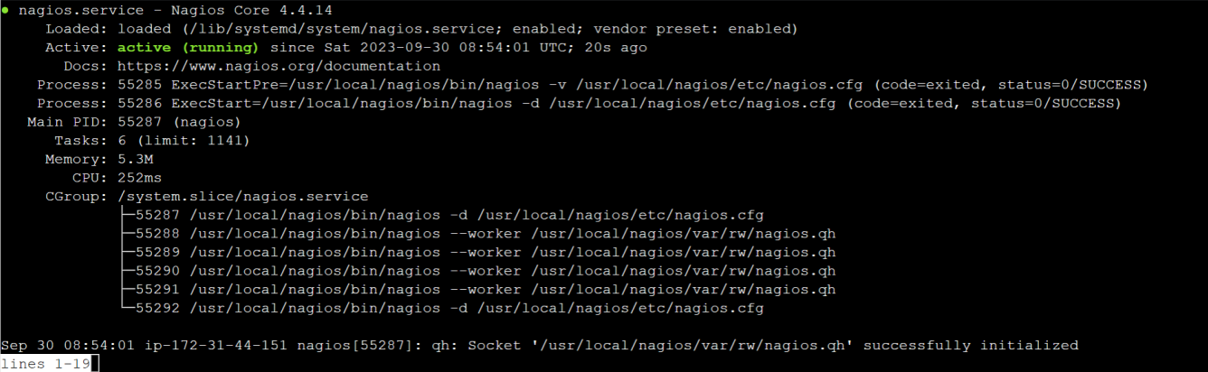

**Step 12:** Now, check your nagios dashboard and you’ll see a new host being added.

